Math 10

Lesson 2–2 Answers

**Lesson Questions**

**Question 1**

Determine each product.

a) (x – 3)(x – 5) b) (5m – 1)(2m – 6)

= x(x – 5) – 3(x – 5) = 5m(2m – 6) – 1(2m – 6)

= x2 – 5x – 3x + 15) = 10m2 – 30m – 2m + 6)

= x2 – 8x + 15 = 10m2 – 32m + 6

**Question 2**

Determine each product.

a) (r – 4)(3r2 + 8r – 6) b) (5x – 3)(2x2 – 6x + 12)

= r(3r2 + 8r – 6) – 4(3r2 + 8r – 6) = 5x(2x2 – 6x + 12) – 3(2x2 – 6x + 12)

= r(3r2 + 8r – 6) – 4(3r2 + 8r – 6) = 5x(2x2 – 6x + 12) – 3(2x2 – 6x + 12)

= 3r3 + 8r2 – 6r – 12r2 – 32r + 24 = 10x3 – 30x2 + 60x – 6x2 + 18x – 36

= 3r3 – 4r2 – 38r + 24 = 10x3 – 36x2 + 78x – 36

**Question 3**

Multiply and then combine like terms.

a) (x + 3)(5x – 2) + 4(x – 1)(2x + 5) b) 2(3x – 2) – (4x + 7)(2x – 5)

= 5x2 + 13x – 6 + 4(2x2 + 3x – 5) = 6x – 4 – (8x2 – 20x + 14x – 35)

= 5x2 + 13x – 6 + 8x2 + 12x – 20 = 6x – 4 – 8x2 + 20x – 14x + 35

= 13x2 + 25x – 26 = – 8x2 + 12x + 31

**Question 4**

When you have three factors, you can multiply in any order.

Multiply 3(2x + 4)(6x – 2) in three ways.

3(2x + 4)(6x – 2)

= (2x + 4)3(6x – 2)

= (2x + 4)(18x – 6)

= 36x2 – 12x + 72x – 24

= 36x2 + 60x – 24

3(2x + 4)(6x – 2)

= (6x + 12)(6x – 2)

= 36x2 – 12x + 72x – 24

= 36x2 + 60x – 24

3(2x + 4)(6x – 2)

= 3(12x2 – 4x + 24x – 8)

= 36x2 – 12x + 72x – 24

= 36x2 + 60x – 24

**Question 5**

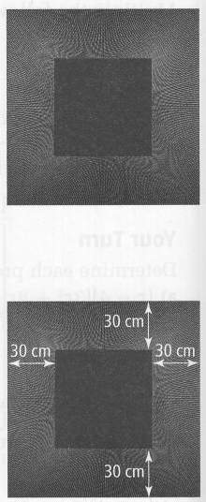

a) Let x represent the length of the red square. The length of the painting can be represented by x + 30 + 30 = x + 60. The area of the painting can be represented by the polynomial expression

(x + 60)(x + 60) = x2 + 120x + 3600.

b) If the red square has an area of 3600 cm2, the side length of the red square is, x =  = 60. Substitute this value into either (x + 60)(x + 60) or x2 + 120x + 3600.

(x + 60)(x + 60)

= (60 + 60)(60 + 60)

= (120)(120)

= 14 400

or

x2 + 120x + 3600

= (60)2 + 120(60) + 3600

= 3600 + 7200 + 3600

= 14 400

The area of the painting is 14 400 cm2.

**Assignment**

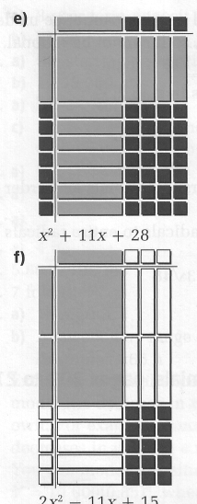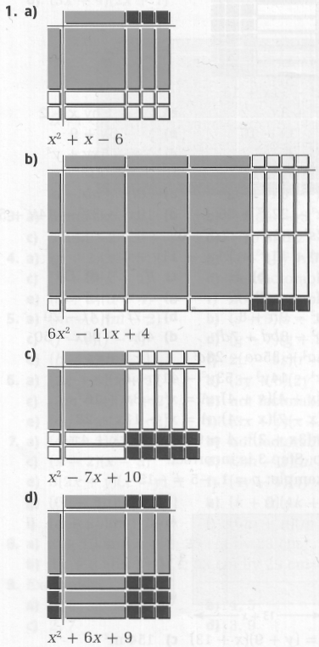

2. a) b)



c) d)



e) f)



3. a) 3x3 – 5x2 + 8x b) 7ab2 +ab – a

c) d)



e) f)



4. a) B b) H c) F d) D

e) J f) E g) A h) G



5. a) b)



c) d)



e) f)



x+4

2

2

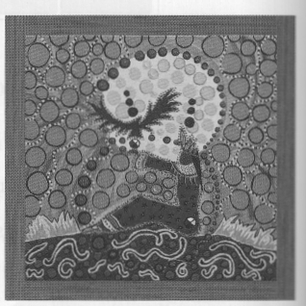

6. A = (x + 4)(x + 4)

A = x2 + 8x + 16

x

7. A = (x – 7)(x – 4); A = x2 – 11x + 28

8. The diameter of the circle is 6x + 4. Radius is ½ the diameter



9. a) No. Step 3 is incorrect, stop after Step 2.

b) You can choose any value for p except zero. I chose p = 1. Evaluate the left side and the right side



Therefore the equation is not true.

10. a)

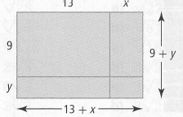

b) A = (y + 9)(x + 13) c) 154 m2

11. a) x + 2 by x – 1

b) A = (x + 2)(x – 1) = x2 + x – 2

c) The new rug has the greater area by 1 ft2.

12. a) A = (3x + 8)(2x + 4) = 6x2 + 28x + 32

b) 1232 cm2

13. a) In the check, the left side does not equal the right side.

b) In step 1, Andre multiplied –4 and 5 to get +20. This is actually equal to –20.

14. a) As the price of a burger increases, the average number of burgers sold decreases.

b)



c)

